CROP RECOMMENDATION SYSTEM

Submitted by:
NABEEHA NAJEEB
SHANZAY IMRAN

Supervisor:
Dr. Imran Khalil

DEPARTMENT OF COMPUTER SCIENCE
UNIVERSITY OF ENGINEERING & TECHNOLOGY PESHAWAR, PAKISTAN
June 2026

Author’s Declaration
We hereby declare that this project report entitled “Crop Recommendation and Fertilizer Recommendation System” is our genuine work and has been conducted under the supervision of our supervisor. This report, neither as a whole nor in parts, has been submitted at any institution, course or qualification.
Additionally, we affirm that academic standards have strictly been followed in all sources of information, primary and secondary data, references, and materials used in this project. We understand that this project report may be used with our consent by the Department of Artificial Intelligence and the University for academic, and reference purposes.

Abstract
Agriculture is one of the most significant sources contributing to food production and economic growth. Variations in soil nutrients and environmental conditions are some of the main issues that farmers face while selecting the appropriate crop for cultivation. Incorrect crop selection can lead to lower yield, causing financial loss. To address this problem, this project presents a Smart Agriculture AI system that recommends the best crops by using Machine Learning Techniques.
Agricultural parameters, including Nitrogen (N), Phosphorus (P), Potassium (K), temperature, humidity, pH value, and rainfall are used by the proposed system as input features. A Random Forest Classifier is exercised on an agricultural dataset to recognise patterns between environmental conditions and crop suitability. The trained model suggests the most suitable crop variety along with fertilizer recommendations for better productivity.
Primarily, Python, Pandas, Scikit-Learn, Joblib, and Streamlit were used to develop this system. Initially, a desktop-based graphical user interface was developed using Tkinter and then converted into a web-based Streamlit application for direct and easy accessibility and utilisation. The trained model attained approximately 99% precision during testing proving its effectiveness and efficiency in crop recommendation.
The developed system provides a user-friendly interface that leads users to directly enter agricultural parameters and receive crop recommendations instantaneously. This project shows how Artificial Intelligence can support improved farming and assist farmers to make informed agricultural decisions.
Keywords: Smart Agriculture, Machine Learning, Crop Recommendation, Random Forest, Streamlit

Acknowledgements
We would like to express our sincere gratitude to Almighty Allah for providing us with the strength and ability to complete this project successfully.
We would like to extend our gratitude to our supervisor for continuous guidance, valuable suggestions, throughout the project development process.
Lastly, we also grateful to the Department of Artificial Intelligence and our university for providing the learning environment and basic resources necessary for the completion of this project.

TABLE OF CONTENTS
Abstract
Acknowledgement
Chapter 1: Introduction
Chapter 2: Literature Review
Chapter 3: Methodology
Chapter 4: Solution and Implementation
Chapter 5: Results and Discussion
Chapter 6: Conclusion and Future Work
References
Appendices
LIST OF FIGURES
System Architecture Diagram
Machine Learning Workflow
Accuracy Graph
Confusion Matrix
GUI Screenshot

LIST OF TABLES
Dataset Features
Model Performance

LIST OF ACRONYMS
AI: Artificial Intelligence
ML: Machine Learning
GUI: Graphical User Interface
RF: Random Forest
NPK: Nitrogen, Phosphorus, Potassium

CHAPTER 1: INTRODUCTION
Background
Agriculture is the main sector of many economies and plays a crucial role in ensuring food and financial security. Farmers are supposed to consider soil conditions and environmental factors before cultivating crops. Making the wrong decision can lead to declined productivity and financial damage.
Recent developments in Artificial Intelligence and Machine Learning have introduced advanced solutions for agricultural sector. Smart farming technologies utilise data-driven techniques to improve productivity, optimize the use of resources, and improve crop yield.
Machine Learning algorithms can analyse larger agricultural datasets and recognise connection between soil nutrients, climate conditions, and crop growth. These elements enable the development of systems that can automatically suggest the appropriate crops for specific environmental conditions.
The Smart Agriculture AI system designed in this project applies Machine Learning techniques to help users in selecting the best crop. The system also provides fertilizer recommendation for the improvement of agricultural productivity.
Problem Statement
Farmers often face difficulties in determining which crop is the most appropriate for their land. Traditional crop selection methods are mainly based on experience and generational knowledge and may neglect some environmental factors.
Incorrect crop selection can result in:
• Reduced crop yield
• Poor soil utilization
• Increased production costs
• Financial damages for farmers
Therefore, there is a need for a smart decision-support system that can evaluate soil and climate conditions and recommend suitable crops precisely.
Objectives
The main objectives of this project are:
• To create an AI-based crop recommendation system.
• To train a Machine Learning model using agricultural data.
• To recommend suitable crops based on N, P, K, temperature, humidity, pH, and rainfall.
• To provide fertilizer suggestions for specific crops and conditions.
• To develop a user-friendly graphical interface.
• To attain high prediction accuracy.
Scope of the Project
This project focuses on crop recommendation using Machine Learning techniques. The system requires agricultural parameters from the user and then predicts the best crops based on learned patterns from the dataset.
The project includes:
• Data preprocessing
• Model training
• Crop prediction
• Fertilizer recommendation
• Web-based deployment using Streamlit
System Architecture
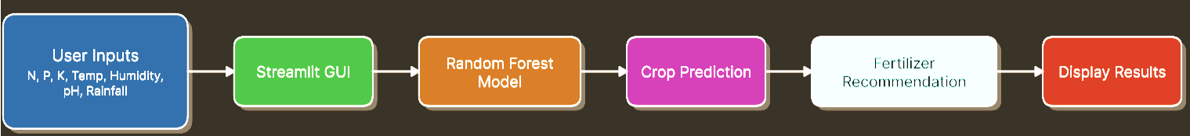
Chapter Summary
This chapter introduced the idea of Smart Agriculture and highlighted the importance of Machine Learning in crop recommendation systems. This chapter included the problem statement, objectives, scope, and system architecture of the proposed solution.

CHAPTER 2: LITERATURE REVIEW
Introduction
Agriculture has significantly benefited from Artificial Intelligence and Machine Learning technologies. Researchers have developed smart systems to upgrade crop selection, yield prediction, irrigation management, and fertilizer recommendations. This chapter reviews previous studies conducted related to crop recommendation and smart agriculture.
Review of Previous Studies
Study 1: Crop Recommendation Using Random Forest
Researchers developed a crop recommendation system using the Random Forest algorithm. Soil and climate parameters were used as primary inputs. The system achieved high accuracy and verified the effectiveness of ensemble learning techniques in agriculture.
Limitation: The system lacked fertilizer recommendations.
Study 2: Smart Agriculture Using IoT
This research incorporated IoT sensors with agricultural systems to collect real-time environmental data. The collected data was used to analyse crop conditions and improve farming decisions.
Limitation: High implementation cost due to hardware requirements.
Study 3: Machine Learning for Crop Yield Prediction
Researchers applied Machine Learning algorithms to predict crop yield based on environmental conditions and historical agricultural data.
Limitation: Focused solely on yield prediction rather than crop selection.
Study 4: Precision Farming Systems
This research focused on precision farming methods that use technology to optimize agricultural resources and increase productivity.
Limitation: This study required special equipment and technical expertise.
Study 5: Artificial Intelligence in Agriculture
Researchers studied different AI applications including crop monitoring, disease detection, irrigation management, and crop recommendation.
Limitation: Many proposed solutions lacked practical utilisation.
Research Gap
Existing studies primarily focus on crop prediction, yield estimation, or environmental monitoring. Very few systems combine crop recommendation, fertilizer recommendation, and user-friendly deployment within a single system. Therefore, this project focuses on providing an integrated solution based on Machine Learning and a web-based interface.
Chapter Summary
This chapter reviewed previous researches conducted related to crop recommendation and intelligent agriculture. The identified research gap motivated the development of the proposed Smart Agriculture AI system.

CHAPTER 3: METHODOLOGY
Introduction
This chapter focuses on the methodology that has been used to develop the Smart Agriculture AI system, including data collection, preprocessing, model training, and deployment.
Data Collection
Kaggle was used to obtain the dataset used for this project.
Input Features
- Nitrogen (N)
- Phosphorus (P)
- Potassium (K)
- Temperature
- Humidity
- pH
- Rainfall
Output
Crop Recommendation.
Data Preprocessing
The following steps were performed in the procedure:
- Dataset loading
- Missing value checking
- Data cleaning
- Feature verification
- Data splitting into training and testing sets
Train-Test Split
The dataset was divided into:
- Training Data: 80%
- Testing Data: 20%
This ensured that the model was evaluated on unseen data.
Model Selection
A Random Forest Classifier was selected because:
- High prediction accuracy
- Handles multiple features effectively
- Reduces overfitting
- Suitable for agricultural datasets
Model Training
The model was trained using the training dataset.
Hyperparameters
- n_estimators = 100
- random_state = 42
- test_size = 0.20
Model Saving
The trained model was saved using Joblib.
Example:
crop_model.pkl
This allows the model to be loaded later without retraining.
System Workflow
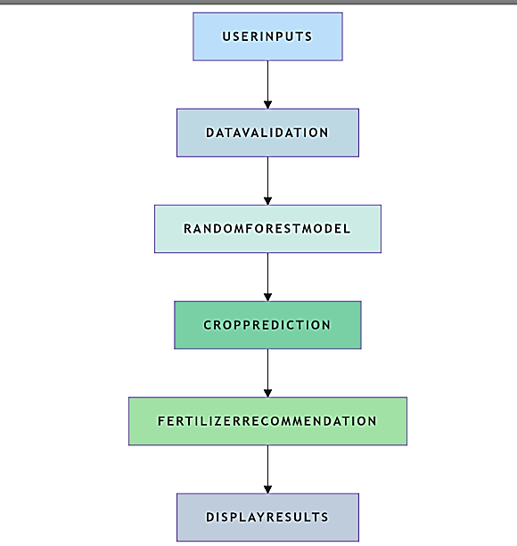
Chapter Summary
This chapter described the complete methodology that was used for developing the Smart Agriculture AI system.

CHAPTER 4: SOLUTION AND IMPLEMENTATION
Software Requirements
- Python 3.x
- Streamlit
- Pandas
- NumPy
- Scikit-Learn
- Joblib
- VS Code
System Implementation
The implementation process consists of:
Step 1: Dataset Loading
Agricultural data is loaded into the system.
Step 2: Data Preprocessing
The dataset is cleaned and prepared for training.
Step 3: Model Training
A Random Forest Classifier is trained using agricultural features.
Step 4: Model Evaluation
The model accuracy is calculated using testing data.
Step 5: Model Storage
The trained model is saved using Joblib.
Step 6: GUI Development
Initially, a Tkinter-based desktop GUI was developed.
Step 7: Streamlit Deployment
The system was later converted into a Streamlit application and deployed online.
User Interface
The GUI allows users to enter:
- Nitrogen
- Phosphorus
- Potassium
- Temperature
- Humidity
- pH
- Rainfall
The system predicts the crop and displays fertilizer recommendations.
Chapter Summary
This chapter focused on the implementation of the proposed Smart Agriculture AI system.

CHAPTER 5: RESULTS AND DISCUSSION
Introduction
This chapter presents the performance evaluation and results obtained from the developed system.
Model Performance
Metric | Value
Accuracy | 99%
Algorithm | Random Forest
Features | 7
The model achieved approximately 99% prediction accuracy.
Accuracy Discussion
The high accuracy demonstrates that the Random Forest algorithm effectively captures relationships between soil nutrients and environmental conditions.
Sample Prediction
Input
Nitrogen = 90
Phosphorus = 42
Potassium = 43
Temperature = 25°C
Humidity = 80%
pH = 6.5
Rainfall = 200 mm
Output
Recommended Crop: Rice
Recommended Fertilizer: Urea
Graphs
Accuracy Graph
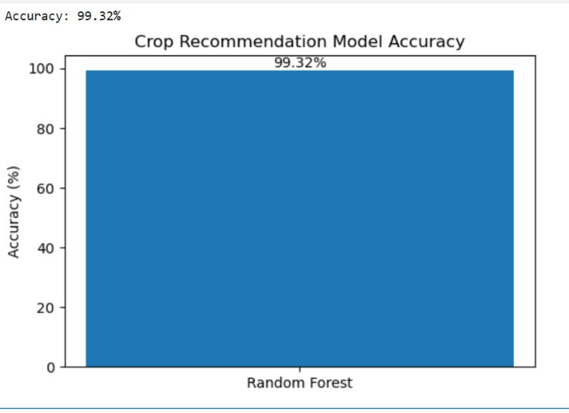
Confusion Matrix
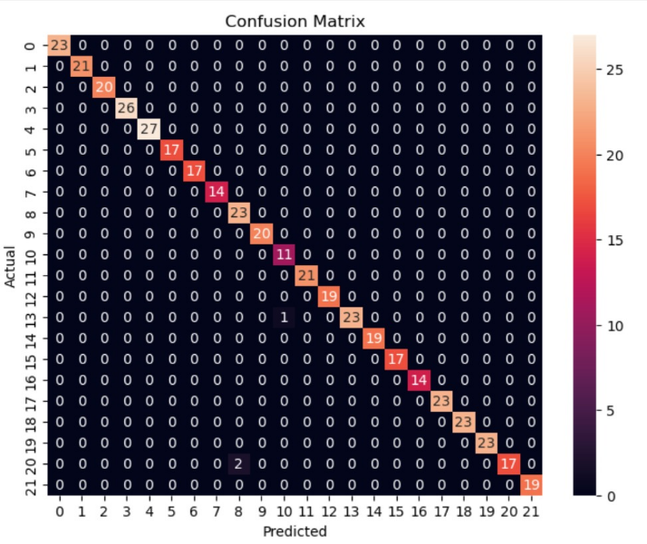
GUI Screenshots
Input Page
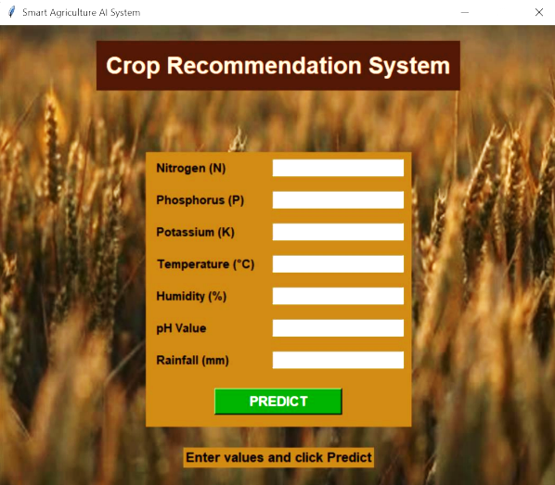
Prediction Page
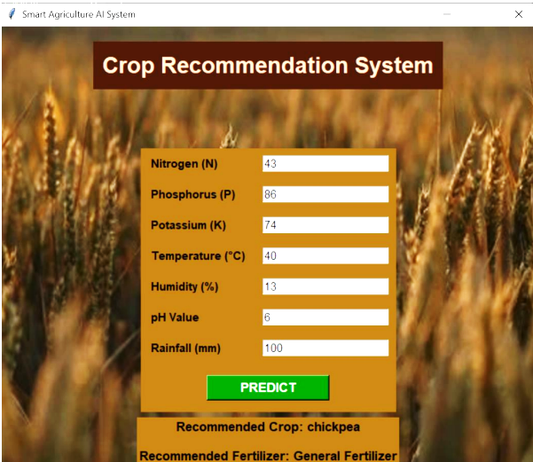
Streamlit Deployment Page
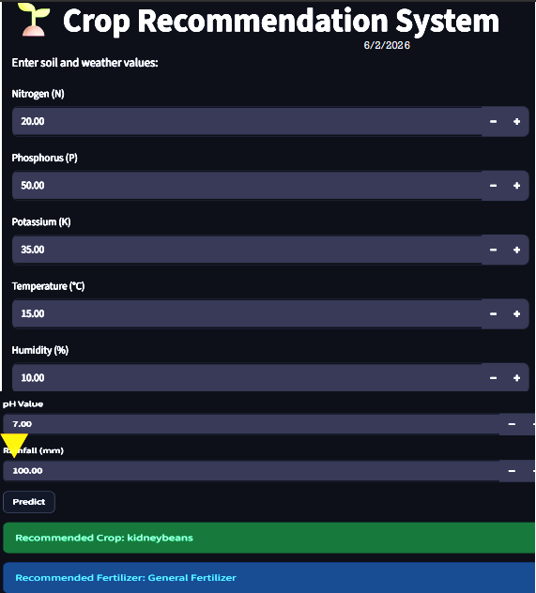
Discussion
The developed system effectively suggests suitable crops based on agricultural inputs. The Streamlit interface provides an easy and accessible platform for users. The fertilizer recommendation feature further improves decision-making support.
Chapter Summary
This chapter discussed the performance results and demonstrated the effectiveness of the Smart Agriculture AI system.

CHAPTER 6: CONCLUSION AND FUTURE WORK
Conclusion
This project effectively developed a Machine Learning-based Smart Agriculture AI system capable of recommending suitable crops using soil and environmental parameters.
The Random Forest Classifier achieved high prediction precision and demonstrated great performance for agricultural decision support. The Streamlit-based interface improved accessibility and serviceability.
The system can help farmers make accurate decisions and improve agricultural productivity.
Limitations
- Dataset size is limited.
- Real-time weather data is not integrated.
- Soil sensor data is not available.
- Predictions depend on dataset quality.
Future Work
Future improvements may include:
- Weather API integration
- IoT sensor connectivity
- Disease detection module
- Mobile application development
- Multilingual support
- Advanced fertilizer recommendation system
Final Remarks
Artificial Intelligence has significant potential to transform the transform the future of agriculture. The developed Smart Agriculture AI system demonstrates how Machine Learning can support intelligent and more efficient farming practices.

REFERENCES
R. Sujatha and P. Isakki, “A Study on Crop Recommendation using Machine Learning,” International Journal of Engineering Research and Technology, vol. 9, no. 5, pp. 120–126, 2020.
S. K. Lakshmi and V. Prasanna, “Machine Learning Approaches in Smart Agriculture,” International Journal of Computer Applications, vol. 177, no. 24, pp. 15–21, 2021.
A. Sharma, R. Kumar, and S. Singh, “Crop Prediction Using Random Forest Algorithm,” International Conference on Artificial Intelligence Applications, pp. 45–52, 2021.
P. Bhosale and M. Patil, “Smart Farming using IoT and Machine Learning,” International Journal of Advanced Research in Computer Science, vol. 11, no. 4, pp. 34–39, 2020.
J. Patel and M. Shah, “Artificial Intelligence in Agriculture,” International Journal of Agricultural Sciences, vol. 12, no. 2, pp. 89–95, 2021.
S. Kumar and A. Verma, “Crop Yield Prediction Using Machine Learning,” IEEE Access, vol. 8, pp. 123456–123468, 2020.
M. Singh et al., “Precision Agriculture using Data Analytics,” International Journal of Data Science, vol. 7, no. 3, pp. 78–84, 2021.
A. Gupta and P. Sharma, “Agricultural Decision Support Systems using AI,” IEEE Conference Proceedings, pp. 112–118, 2022.
Kaggle, “Crop Recommendation Dataset,” Available Online.
Scikit-Learn Documentation, “Random Forest Classifier,” Available Online.

END

